Test 2 Galvez Notes

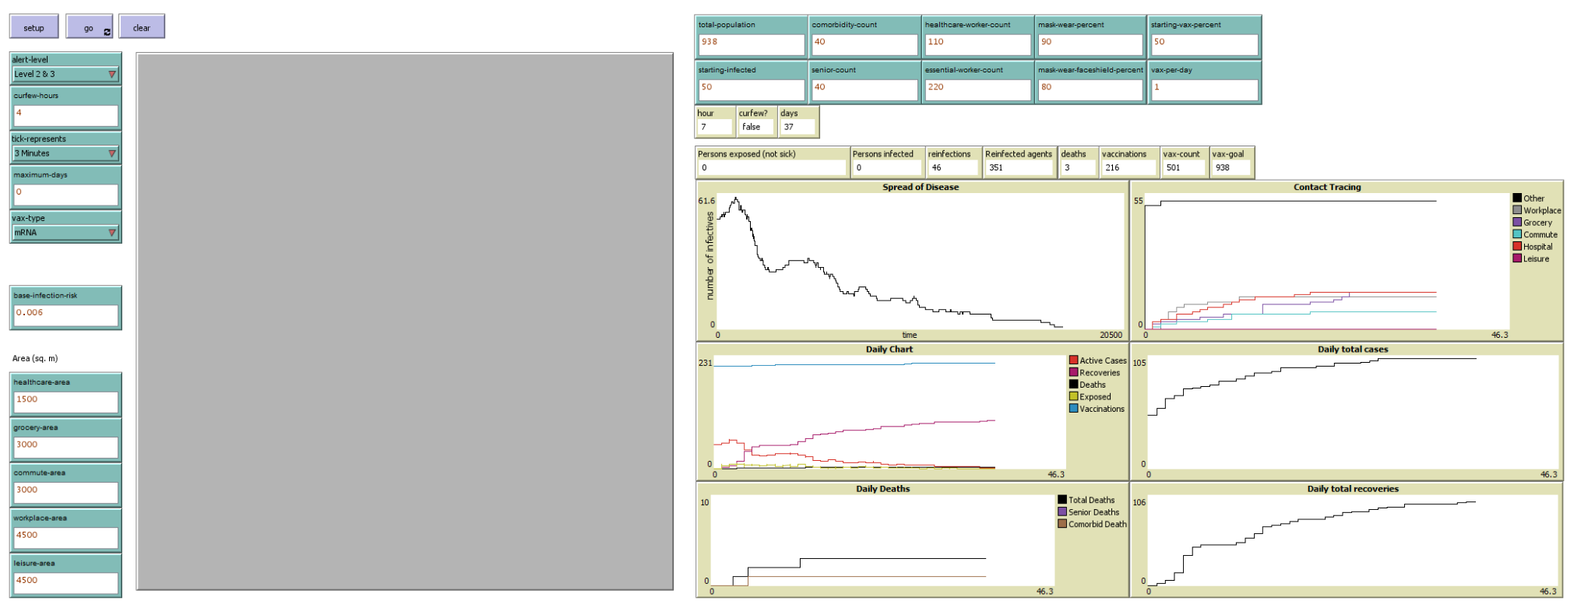

* Alert level 2 & 3
* 4 hour curfew
* mRNA vax

